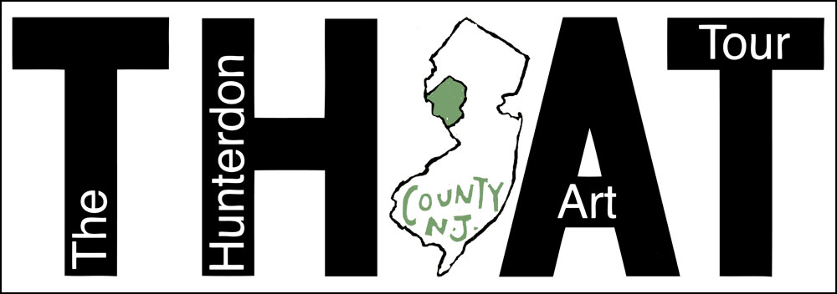
www.thehunterdonarttour.com

WHAT: Self-guided tour of artist’s studios, open to the public for the occasion

WHEN: May 6-7, 2017 (Saturday and Sunday)

WHO: Artists, arts organizations and business partners in Hunterdon County

WHY: Hunterdon County is brimming with artists. Our aim is to raise their profile, fill their pockets and make Hunterdon County an annual destination for the world to see what our artists are creating. In addition, the tour will bring travellers to our restaurants, hotels and businesses and foster our guests’ appreciation for the lands we call home and the beauty that many have worked to preserve.

MORE: In early April, six artists gathered to initiate the conversation towards forming an open studios event in Hunterdon County. Later that month, twenty-four artists attended a second meeting, hosted by the Hunterdon County Cultural and Heritage Commission, and support for the project was clear.

The Hunterdon Art Tour (THAT) will:

- Provide an exceptional forum for showcasing Hunterdon County’s diverse and talented artists by pulling together ALL OF THE ART ORGANIZATIONS in Hunterdon County.

- Promote Hunterdon County as an ARTS DESTINATION, presenting a unique opportunity for residents and visitors to engage with artists in their studios, with local businesses and our twenty-six vibrant municipalities.

- BUILD COMMUNITY AMONG ARTISTS by deepening existing relationships and forging new connections.

Essential to achieving our objectives is a strong and functional website that meets the needs of all the users: artists, organizers and visitors (i.e. the “tour”ists). We have secured the URLs: www.thehunterdonarttour.com/.org/.net. Preliminary information about THAT is posted there.

We now have eighty names on an email list, a budget, a logo, a website address, a steering committee and … momentum! We are delighted to have joined with River Union Stage as our first community partner for this effort. The Hunterdon County Cultural and Heritage Commission and the Hunterdon Museum of Art have also joined us as partners. We look forward to implementing a robust outreach plan to identify additional partners, sponsors and participants.

Contact us @ hunterdonarttour@gmail.com

